Step 1: Define System Requirements and Objectives - Clearly define the objectives and requirements of your traffic management system. Consider factors like traffic monitoring, congestion detection, and data analysis

Step 2: Choose Sensors and Cameras - Select the appropriate sensors and cameras for your system. Common choices include: - Traffic flow sensors (e.g., ultrasonic or infrared sensors) - Vehicle detection cameras (e.g., Raspberry Pi Camera Module or USB webcams) - Environmental sensors (e.g., temperature, humidity) - Traffic light control cameras (for monitoring traffic light status) - License plate recognition cameras (optional, for more advanced features)

Step 3: Set Up Raspberry Pi - Prepare your Raspberry Pi 3 by installing the necessary operating system (e.g., Raspbian). - Connect the selected sensors and cameras to the Raspberry Pi using the appropriate interfaces (e.g., USB, GPIO pins) Install the required software libraries and drivers for the sensors and cameras

Step 4: Develop IoT Software - Write code to interface with the sensors and cameras. You may use programming languages like Python. Create an IoT application on the Raspberry Pi that collects data from sensors and cameras and processes it. You can use IoT frameworks like Azure IoT SDK for Python. Implement data preprocessing and filtering to ensure the quality of the data being sent to the cloud.

Step 5: Azure IoT Hub Setup - Sign in to your Azure account and set up an Azure IoT Hub. Register your Raspberry Pi as a device in the IoT Hub and obtain the connection string

Step 6: Azure IoT Cloud Simulator - Set up and configure the Azure IoT Cloud Simulator: - Create a new Azure IoT Central application or IoT solution. Create device templates and define telemetry, properties, and commands. Configure device simulation models based on your Raspberry Pi's behavior. Simulate data streams from your virtual devices

Step 7: Data Transmission - Modify your Raspberry Pi code to send sensor data to the Azure IoT Hub using the connection string obtained earlier. Ensure proper security measures are in place for data transmission (e.g., using TLS)

Step 8: Data Processing and Analysis - In Azure, set up services (e.g., Azure Stream Analytics, Azure Functions, or Azure Machine Learning) to process and analyze the incoming data. - Implement traffic

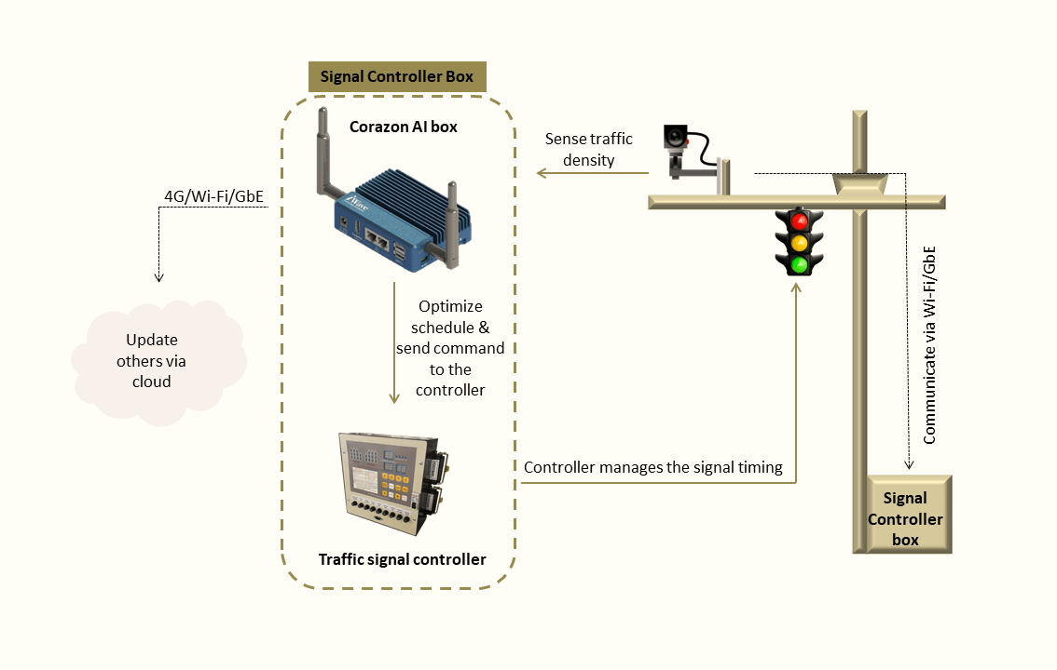

Step 9: Visualization and User Interface - Create a web-based or mobile dashboard to visualize real-time traffic data and system status. Use Azure services like Azure Web Apps or Power BI for this purpose.

Step 10: Testing and Optimization - Test the entire system thoroughly, including sensor accuracy, data transmission, cloud processing, and visualization. Optimize your system for performance, scalability, and reliability.

Step 11: Deployment - Once satisfied with testing and optimization, deploy your traffic management system in the desired location.

Step 12: Monitoring and Maintenance - Implement monitoring and maintenance procedures to ensure the system